Recent earthquake in Nepal
Narayan Gautam
Lecturer
Tribhuvan University
Kathmandu, Nepal

Nepal is located between India and China and the country is situated in one of the seismically active zones. On April 25, 2015, Nepal faced disastrous earthquake having 7.6 magnitude scale¹. The earthquake occurred at11.56 AM of Nepal local time and its epicenter was in Barpak village development committee of Gorkha district. The epicenter is located 28.24ºN latitude and 84.75ºE longitude and about 83 km away from the capital city, Kathmandu². In the history of Nepal, it is one of the massive earthquakes after Nepal-Bihar earthquake of 1934³.

On an official record of May 26, 2015 the Gorkha earthquake caused fatalities of more than 8,600 people, about 22,000 people were injured and more than 500,000 houses were fully destroyed⁴. The following table is made by considering the recent earthquakes data obtained till May 26, 2015 and it shows that four major aftershocks were occurred greater than 6 magnitude scale after the Gorkha earthquake. And, those major aftershocks were also became reasons to amplify casualties and property damage in the earthquake prone areas.

Recent earthquakes greater than 6 magnitude scale⁵
Date | Local Time | Latitude | Longitude | Magnitude(ML) | Epicentre
2015/04/25 | 11:56 | 28.24 | 84.75 | 7.6 | Gorkha
2015/04/25 | 12:30 | 28.28 | 84.72 | 6.6 | Gorkha
2015/04/26 | 12:54 | 27.84 | 86.05 | 6.9 | Sindhupalchowk/Dolakha
2015/05/12 | 12:50 | 27.82 | 86.12 | 6.8 | Dolakha/Shindhupalchok
2015/05/12 | 13:21 | 27.73 | 86.21 | 6.2 | Dolakha

The Government of Nepal has initially estimated 6.7 billion USD for reconstruction of earthquake damaged sectors on its Post Disaster Needs Assessment (PDNA) report⁶. Due to the Gorkha earthquake and aftershocks, land-fractures are largely seen in most of the earthquake affected districts and it has also intensified the chances of various types of water induced disasters including landslides, floods and sedimentation throughout the country.

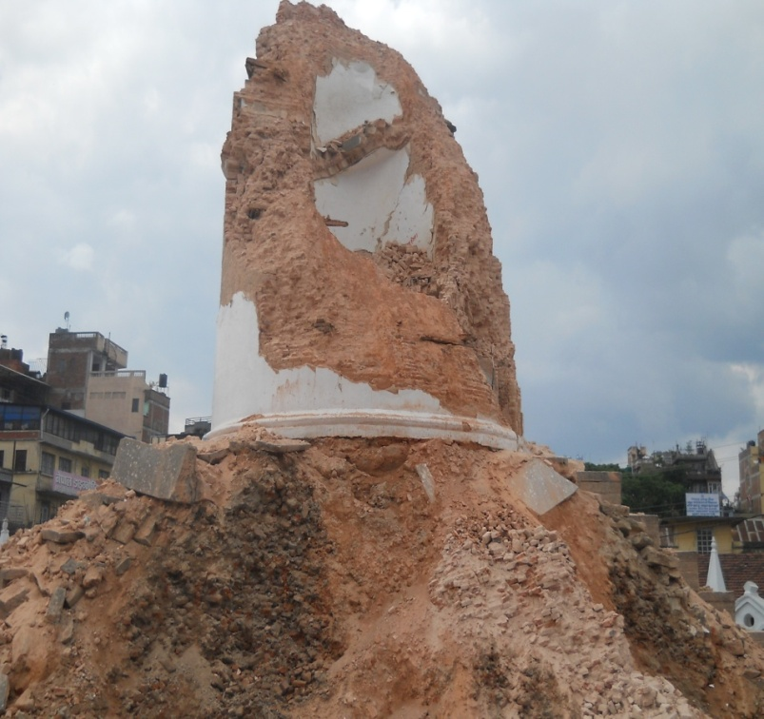
Damage of Bhimsen stambha (Dharahara) by the Gorkha-earthquake (Photo by Narayan)

References
1 NEOC. http://neoc.gov.np/uploads/cmsfiles/file/earthquake_20150425073950.PDF. Nepal Government, Ministry of Home Affairs, National Emergency Operation center, accessed 15 June 2015.

2 SDMC. http://saarc-sdmc.nic.in/pdf/nepal%20eq.pdf. SAARC Disaster Management Centre, accessed 15 June 2015.

3 NSET. http://www.nset.org.np/eq2015/ Accessed 15 June 2015.

4 GON. http://drrportal.gov.np/uploads/document/175.pdf. Government of Nepal, accessed 15 June 2015.

5 NSC. www.seismonepal.gov.np/index.php?linkID=56. Government of Nepal, Ministry of Industry, Department of Mines and Geology, Accessed 26 May 2015.

6 The Himalayan Times. http://thehimalayantimes.com/kathmandu/top-un-official-hails-nepal-for-successful-icnr/ Accessed 30 June 2015.
Optional

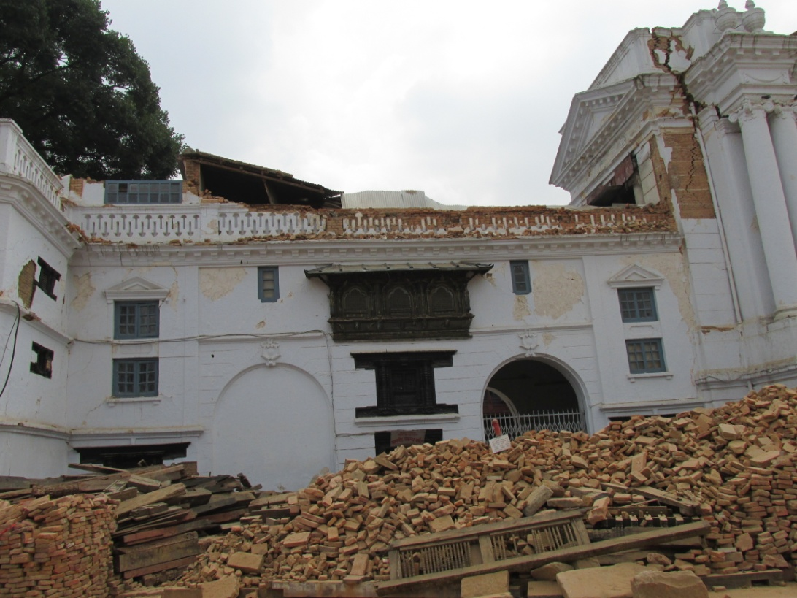
Damage in a historical palace at Hanumandhoka durbar square, Kathmandu (Photo by Narayan)

